Downloading packages/file from different directories and installing in kali

sudo add-apt-repository ppa:webupd8team/java
sudo apt-get update

output::::::
apt-get update
Hit:1 http://ftp.debian.org/debian stretch-backports InRelease
Ign:2 http://ppa.launchpad.net/webupd8team/java/ubuntu jammy InRelease
Err:4 http://ppa.launchpad.net/webupd8team/java/ubuntu jammy Release
404 Not Found [IP: 91.189.95.85 80]
Hit:3 http://ftp.harukasan.org/kali kali-rolling InRelease
Reading package lists... Done
E: The repository 'http://ppa.launchpad.net/webupd8team/java/ubuntu jammy Release' does not have a Release file.
N: Updating from such a repository can't be done securely, and is therefore disabled by default.
N: See apt-secure(8) manpage for repository creation and user configuration details.

Man apt-secure checking the manual page of apt-secure
apt-secure - Archive authentication support for APT

DESCRIPTION
Starting with version 0.6, APT contains code that does signature checking of the Release file
for all repositories. This ensures that data like packages in the archive can't be modified by
people who have no access to the Release file signing key. Starting with version 1.1 APT
requires repositories to provide recent authentication information for unimpeded usage of the
repository. Since version 1.5 changes in the information contained in the Release file about
the repository need to be confirmed before APT continues to apply updates from this
repository.

Note: All APT-based package management front-ends like apt-get(8), aptitude(8) and synaptic(8)
support this authentication feature, so this manpage uses APT to refer to them all for
simplicity only.

UNSIGNED REPOSITORIES
If an archive has an unsigned Release file or no Release file at all current APT versions will
refuse to download data from them by default in update operations and even if forced to
download front-ends like apt-get(8) will require explicit confirmation if an installation
request includes a package from such an unauthenticated archive.

You can force all APT clients to raise only warnings by setting the configuration option
Acquire::AllowInsecureRepositories to true. Individual repositories can also be allowed to be
insecure via the sources.list(5) option allow-insecure=yes. Note that insecure repositories
are strongly discouraged and all options to force apt to continue supporting them will
eventually be removed. Users also have the Trusted option available to disable even the
warnings, but be sure to understand the implications as detailed in sources.list(5).

A repository which previously was authenticated but would loose this state in an update
operation raises an error in all APT clients irrespective of the option to allow or forbid
usage of insecure repositories. The error can be overcome by additionally setting
Acquire::AllowDowngradeToInsecureRepositories to true or for Individual repositories with the
sources.list(5) option allow-downgrade-to-insecure=yes.

How do I bypass/ignore the gpg signature checks of apt?
Asked
Active 2 years, 8 months ago
Viewed 260k times

72
16
All of the key-servers I visit are timing out. I need to install packages without checking the signatures of the public keys. Is there a way to bypass all the signature checks/ignore all of the signature errors or fool apt into thinking the signature passed?

I am very well aware it is dangerous to do this

Pass the --allow-unauthenticated option to apt-get as in:
sudo apt-get --allow-unauthenticated upgrade
From tha manual page of apt-get:
--allow-unauthenticated
Ignore if packages can't be authenticated and don't prompt about it. This is useful for tools like pbuilder. Configuration Item: APT::Get::AllowUnauthenticated.
You can make this setting permanent by using your own config file at /etc/apt/apt.conf.d/ dir. The filename can be 99myown and it may contain this line:
APT::Get::AllowUnauthenticated "true";
In this way, you don't need to use the option every time you want to install software. Note: I do not recommend setting this option by default, it bypasses signature checks that could allow an adversary to compromise your computer.

How to remove an apt repository which seems to be showing up after sudo apt update in the terminal but not present in /etc/apt/sources.list.d?
I accidentally added a repository with sudo add-apt-repository "deb http://archive.canonical.com/ $(lsb_release -sc) partner" and since then I am getting an error whenever I try the sudo apt update command. I am pretty sure its because of the above repository. I searched on google and found out that the repository can be removed by manually visiting the /etc/apt/sources.list.d/ folder but the above repository is not present there. I have also tried the ppa-purge but was unable to remove the repository. How do I remove the above repository?
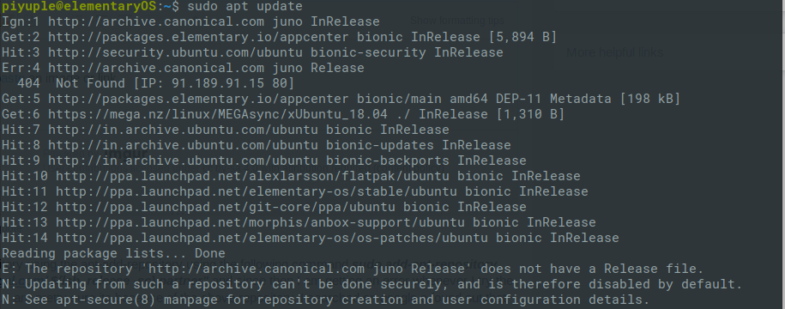
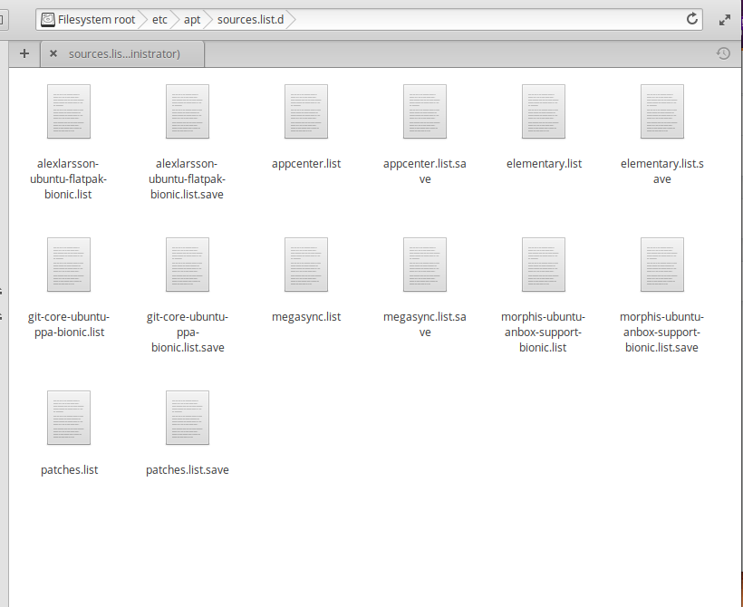

2 Answers

1
According to the man page you can use the same command with the -r option to remove the repository:
sudo add-apt-repository -r "deb http://archive.canonical.com/ $(lsb_release -sc) partner"
I didn't fully understand in which case a new repository file is added to the /etc/apt/sources.list.d directory, but if it's not there, then it must have been added to your /etc/apt/sources.list and you can also remove it manually from there.

2
The man page (man add-apt-repository) says that it manages repositories not only under the directory /etc/apt/sources.list.d/ but also in the file /etc/apt/sources.list.
If you can't find a reference to your unwanted repository under /etc/apt/sources.list.d you should also check the file /etc/apt/sources.list.
As mentioned already the documentation also describes the -r (--remove-) flag to remove an existing repository.

Ways to Remove PPAs Package Added in Ubuntu Linux



Introduction
Here in the article, we’ll walk you through the steps for removing a package on Ubuntu using both the GUI and command line in the following Ubuntu removing package guide. We’ll also demonstrate how to remove a package. Choose the ways that are most convenient for you from the options below. If you want to remove packages from your Ubuntu Linux system, you can do it in a few different ways.
In this article, we will be learning the different ways to remove packages in the Ubuntu Linux with both GUI and the command line. Firstly, the GUI ways are shown with the example and secondly, the command line methods are shown with examples and commands.

Using GUI
One of the ways to remove the packages in Ubuntu Linux is using the software and updates app available in the GUI of the Linux. Launch the app from the application lists or by searching it in the search bar. Now, after the app is opened click on the Other software button which is located in the top side. Here, all the available packages are listed. Select the desired packages to remove and click the remove button.

MY LATEST VIDEOS
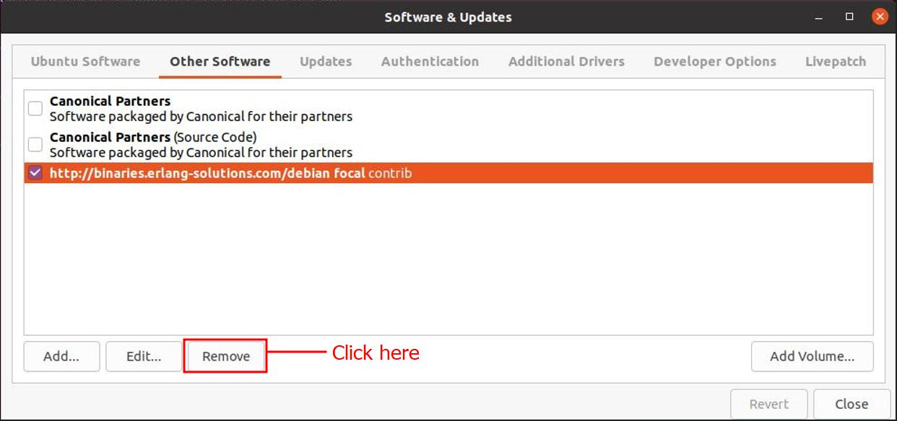

The system will ask for the user to authenticate before removing the packages. You must enter the password of the system and click the Authenticate button as shown below. After the process is done you will remove the package.

Via Command line
There are different ways to remove packages using commands in the command line via terminal. Few of them are mentioned below with examples and commands.

1. Using add-apt-repository
Add or remove packages repositories from the /etc/apt/sources.list.d directory with the add-apt-repository command. Simply use the add-apt-repository command in the following syntax to delete a packages repository from your system. The below command will remove the packages using the apt command.
Sam@Linuxways:~$ sudo apt-repository -r package_name
Here, using the apt command the packaged erlang solution is being removed.
Sam@Linuxways:~$ sudo add-apt-repository -r erlang-solution

2. Using the path of lists
The /etc/apt/sources.list.d directory contains all the lists of the available repositories in the Linux system. Path to the directory using the cd command and type ls command to list the repository.
To path to the directory cd command is used as shown below:
Sam@Linuxways:~$ cd /etc/apt/sources.list.d
Now, to list all the repositories available in the system type ls command as shown below:
Sam@Linuxways:~$ ls
Finally, to remove the desired repository use the rm command as shown below:
Syntax:
Sam@Linuxways:~$ sudo rm packages_name
Here, the package erlang solution is removed using the rm command.
Sam@Linuxways:~$ sudo rm erlang-solutions.list
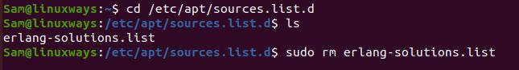

Using purge
The default removal command simply removes software files from the system, but it keeps all configuration files for safety. The configuration and data files are safe if they are accidentally deleted.Use the –purge argument with the below command to entirely erase all data, application, and configuration files. like:
Syntax:
Sam@Linuxways:~$ sudo apt remove - -purge [package-name]
Here, the package is removed using the purge command with apt.
Sam@Linuxways:~$ sudo apt remove - -purge erlang-solutions
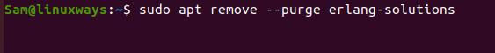

There are a number of options:
- Use the --remove flag, similar to how the PPA was added:
sudo add-apt-repository --remove ppa:whatever/ppa
- You can also remove PPAs by deleting the .list files from /etc/apt/sources.list.d directory.
- As a safer alternative, you can install ppa-purge:
sudo apt-get install ppa-purge
And then remove the PPA, downgrading gracefully packages it provided to packages provided by official repositories:
sudo ppa-purge ppa:whatever/ppa
Note that this will uninstall packages provided by the PPA, but not those provided by the official repositories. If you want to remove them, you should tell it to apt:
sudo apt-get purge package_name
- Last but not least, you can also disable or remove PPAs from the "Software Sources" section in Ubuntu Settings with a few clicks of your mouse (no terminal needed).

How to remove nodejs from nodesource.com?
Asked
Modified 4 years, 9 months ago
Viewed 14k times

14
4
I have installed nodejs from nodesource.com:
curl -sL https://deb.nodesource.com/setup_0.12 | sudo bash -

sudo apt-get install nodejs
It installed nodejs 0.12.4, but how can i remove it now including all footprints from that repo?
I can see a file under /etc/apt/sources.list.d/nodesource.list
nodejs
Share
Improve this question
edited May 28, 2015 at 10:34

Maythux
78.1k5151 gold badges229229 silver badges265265 bronze badges
asked May 28, 2015 at 10:22

Alexander Kim
1,13055 gold badges1515 silver badges2525 bronze badges
Add a comment

3 Answers

22
First you can purge nodejs and its related files
sudo apt-get purge nodejs
then you can delete the its repositoy
sudo rm -r /etc/apt/sources.list.d/nodesource.list
Share
Improve this answer
answered May 28, 2015 at 10:34
Maythux
78.1k5151 gold badges229229 silver badges265265 bronze badges
- That's all? Nothing more?
– Alexander Kim
May 28, 2015 at 10:36
- @Heihachi yes that's is
– Maythux
May 28, 2015 at 10:39
Add a comment

6
As addition, you may want to remove nodesource key.
First you can see:
sudo apt-key list
And it will output something look like this
pub 4096R/68576280 2014-06-13
uid NodeSource <gpg@nodesource.com>
sub 4096R/AA01DA2C 2014-06-13
Then you can delete with:
sudo apt-key del 68576280
Share
Improve this answer
answered Jun 18, 2015 at 4:31

bentinata
16133 bronze badges
Add a comment

1
sudo apt-get purge nodejs
But this won't delete the /usr/lib/node_modules directory as its not empty.
So for a complete clean up, run:
sudo rm -r /usr/lib/node_modules/
sudo rm /etc/apt/sources.list.d/nodesource.list

